**Project COVID-19 Trend under Age Structure and Medical Supply**

# Content

Overview

System Requirements

Installation Guide

Demo

License

# Overview

Data driven technique designed for projecting COVID-19 trend under nonidentity of countries or areas. To take the nonidentity of social factors into consideration, the correlation of factors, such as age ratio and medical workers and COVID dynamic transmission is presented and the embedded distance is developed to link the similarity relationship over time dimension. With nearest neighbor criterion, we provide the method for dynamic transmission forecasting for arbitrary cases, which help us to learn the functions of indirect impacts during virus spreading.

# System Requirements

## Hardware Requirements

The package requires only a standard computer with enough RAM to support the operation defined by a user. For minimal performance, this will be a computer about 2GB of RAM. For optimal performance, we recommend a computer with the following specs:

RAM: 16+ GB

CPU: 4+ cores, 3.3+GHz/core

## Software Requirements

### OS Requirements

The package development version is tested on Windows operating system.

### MATLAB Requirements

Verify that version 9.4(R2018a) of the MATLAB Runtime is installed. If not, you can run the MATLAB Runtime installer. To find its location, enter:

>>mcrinstaller

Alternatively, download and install the Windows version of the MATLAB Runtime for R2018a

from the following link on the MathWorks website:

http://www.mathworks.com/products/compiler/mcr/index.html

For more information about the MATLAB Runtime and the MATLAB Runtime installer, see

Package and Distribute in the MATLAB Compiler documentation

in the MathWorks Documentation Center.

# Installation Guide

Download the package in your computer and you can use it by opening projection_COVID19.exe.

# Demo

## Correlation Estimation

Chose the social factors (age structure or medical supply) on “Factor” dropdown box and press the “apply” bottom. The correlation with factors and COVID-19 trend is present on the three axes. You can choose specific parameters and get time-variant quantify results by moving slide as Fig.1.

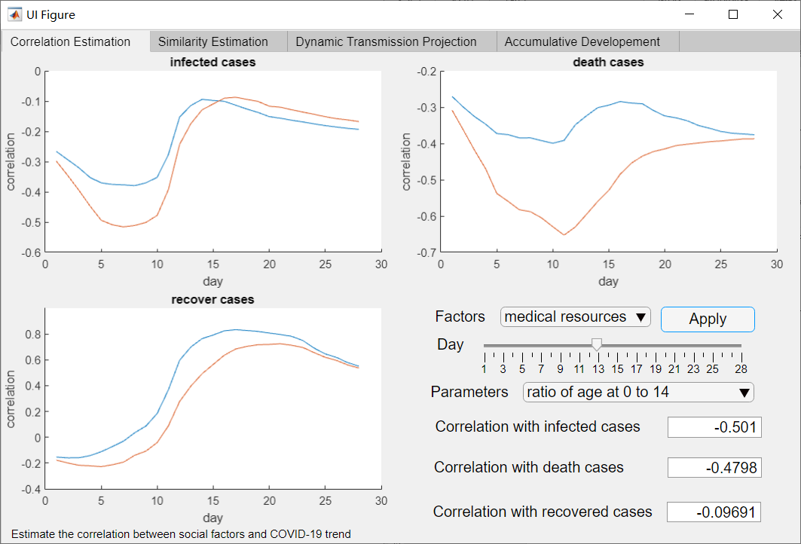

**Fig.1** Correlation estimation with social factors.

## Similarity Estimation

By choosing the parameter in extreme IR model and press the “Apply” bottom, the histogram and estimation of projection accuracy and embedded distance is shown in the two axes as Fig.2. By moving the “distance” slides, the quantify results will be presented on the “Result” panel.

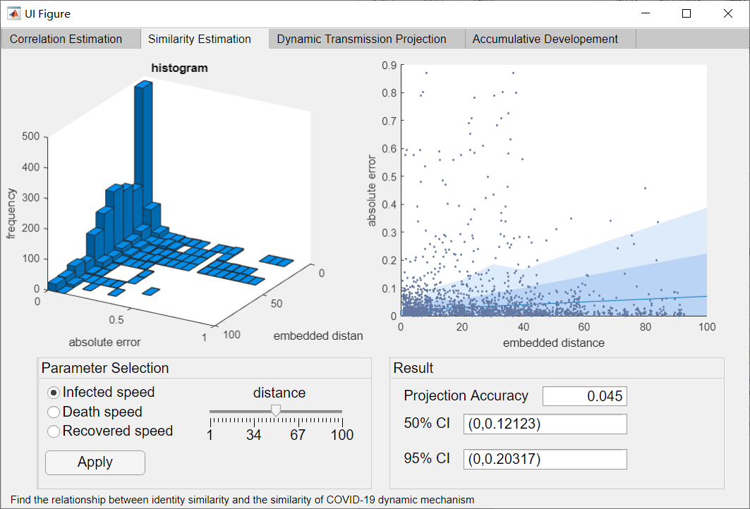

**Fig.2** Similarity Estimation

## Dynamic Transmission Projection

To get projection in range of parameters, here enter the minimum value, maximum value and step length of the selected parameter. If you want to get controlled-parameter result, choose “Set other parameter into average”, else enter the set value for other parameters, push the “Project” Bottom to get the results.

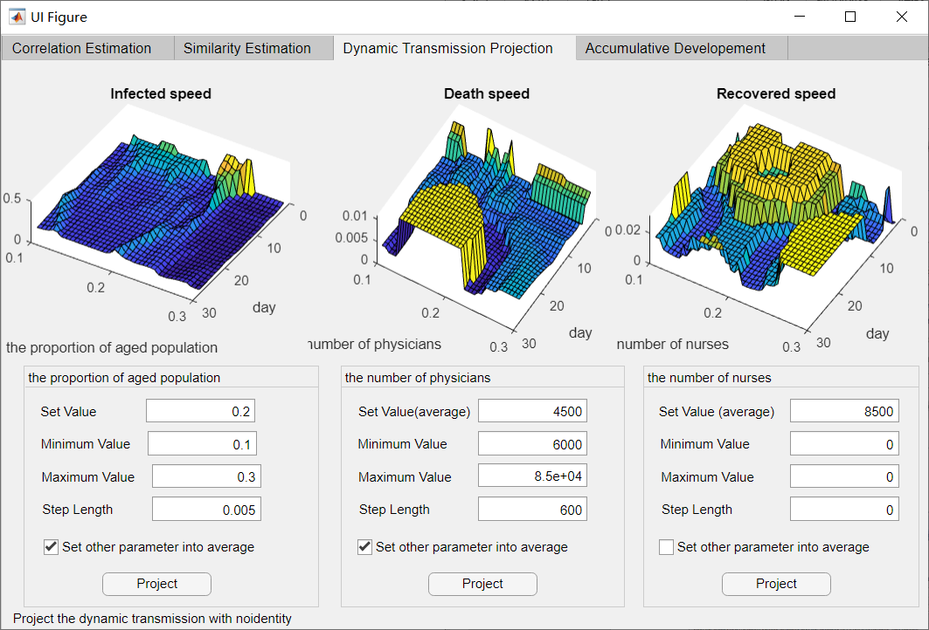

**Fig.3** Dynamic Transmission Projection

## Accumulative Development

To see the time-dimension change on transmission, we provide two types of testing cases. The first type is parameter-controlled cases which can be chosen in “Test Case” panel and the details about test cases are in the manuscript. The second type of cases is country cases with real information of countries. You can choose the cases in the drop-down box and press apply to get the development projection. Also, you can enter the parameter in “ Custom Cases ” Panel to get dynamic projection of arbitrary cases and observe difference between transmission dynamics by changing the set of parameter values.

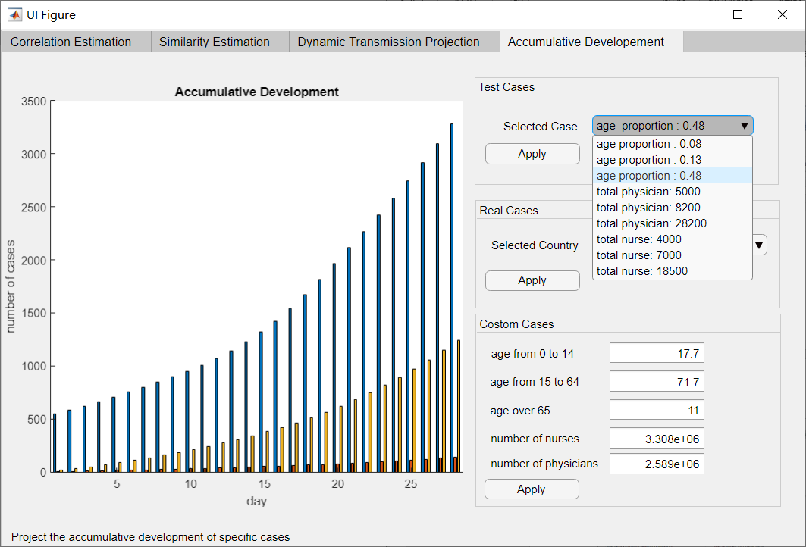

# License

The package requires no license.